Commitment of traders (COT) analysis and modeling

Preliminary results

Table of Contents

Executive Summary 2

WTI 6

Commercials 6

Nowcasting 6

Forecasting 10

Managed Money 13

Nowcasting 14

Forecasting 18

Brent 22

Commercials 22

Nowcasting 22

Forecasting 26

Managed Money 30

Nowcasting 30

Forecasting 34

Heating Oil 36

Commercials 36

Nowcasting 36

Forecasting 40

Managed Money 44

Nowcasting 44

Forecasting 47

RBOB 52

Commercials 52

Nowcasting 52

Forecasting 56

Managed Money 60

Nowcasting 60

Forecasting 64

# Executive Summary

|  |  |  |  |  |
| --- | --- | --- | --- | --- |
| WTI Commercials | | | | |
|  |  | Selected Features | Best Model | OOS Performance |
| Nowcasting | Long | 'F3_RolledPrice_change'  'prior_5D_F1_OI_change'  'prior_5D_AGG_OI_change' | {'model_name': 'rf',  'params': {'n_estimators': 1200,  'max_depth': 20,  'min_samples_leaf': 3,  'max_features': 'sqrt'}} | 0.46 |
| Short | 'F3_RolledPrice_change',  'prior_5D_F1_OI_change',  'prior_5D_AGG_OI_change' | {'model_name': 'rf',  'params': {'n_estimators': 1000,  'max_depth': 25,  'min_samples_leaf': 1,  'max_features': 'sqrt'}} | 0.41 |
| Net | 'prior_cumulative_5D_F1MinusF2_Volume_change',  'prior_report_SyntheticF1MinusF2_RolledPrice_change',  'F2_RolledPrice_change' | {'model_name': 'extra',  'params': {'n_estimators': 600,  'max_depth': 11,  'min_samples_leaf': 1,  'max_features': 'sqrt'}} | 0.116 |
| Long/OI | 'prior_report_SyntheticF1MinusF2_RolledPrice_change',  'prior_5D_F1_OI_change',  'prior_cumulative_5D_F1MinusF2_Volume_change' | {'model_name': 'rf',  'params': {'n_estimators': 600,  'max_depth': 27,  'min_samples_leaf': 8,  'max_features': 'log2'}} | 0.21 |
| Short/OI | 'F3_RolledPrice_change',  'prior_5D_F1_OI_change',  'prior_cumulative_5D_F1MinusF2_Volume_change' | {'model_name': 'rf',  'params': {'n_estimators': 200,  'max_depth': 30,  'min_samples_leaf': 1,  'max_features': 'log2'}} | 0.12 |
| Net/OI | 'prior_cumulative_5D_F1MinusF2_Volume_change',  'prior_report_Commercial_NetPosition_change',  'F1_RolledPrice_change' | ols | 0.1 |
| Forecasting | Long | 'prior_report_CommercialShortPosition_change',  'prior_cumulative_5D_F2_Volume_change',  'prior_5D_F2_OI_change',  'prior_cumulative_5D_F1MinusF2_Volume_change',  'prior_5D_F1MinusF2_openinterest_change' | {'model_name': 'rf',  'params': {'n_estimators': 800,  'max_depth': 18,  'min_samples_leaf': 2,  'max_features': 'sqrt'}} | 0.39 |
| Short | 'prior_report_CommercialShortPosition_to_openinterest_change',  'prior_cumulative_5D_F2_Volume_change',  'prior_5D_F2_OI_change',  'prior_cumulative_5D_F1MinusF2_Volume_change',  'prior_5D_F1_OI_change' | {'model_name': 'rf',  'params': {'n_estimators': 600,  'max_depth': 12,  'min_samples_leaf': 3,  'max_features': 'sqrt'}} | 0.4 |
| Net | 'prior_5D_AGG_OI_change',  'F3_RolledPrice_rolling_20D_volatility',  'F1_RolledPrice_change' | ols | 0.05 |
| Long/OI | 'F2_RolledPrice_rolling_20D_volatility',  'prior_report_CommercialLongPosition_change',  'prior_report_CommercialShortPosition_change',  'prior_5D_F2_OI_change',  'prior_5D_F1MinusF2_openinterest_change' | {'model_name': 'rf',  'params': {'n_estimators': 600,  'max_depth': 14,  'min_samples_leaf': 7,  'max_features': 'sqrt'}} | 0.226 |
| Short/OI | 'prior_cumulative_5D_F1MinusF2_Volume_change',  'prior_report_CommercialLongPosition_change',  'prior_report_CommercialShortPosition_to_openinterest_change',  'prior_cumulative_5D_F2_Volume_change',  'prior_5D_F1_OI_change' | {'model_name': 'rf',  'params': {'n_estimators': 200,  'max_depth': 22,  'min_samples_leaf': 1,  'max_features': 'log2'}} | 0.228 |
| Net/OI | 'F1_RolledPrice_change',  'F2_RolledPrice_rolling_20D_volatility',  'prior_5D_F1_OI_change' | ols | 0.09 |

|  |  |  |  |  |
| --- | --- | --- | --- | --- |
| WTI Managed Money | | | | |
|  |  | Selected Features | Best Model | OOS Performance |
| Nowcasting | Long | 'prior_report_ManagedMoney_ShortPosition_to_openinterest_change',  'prior_5D_F1_OI_change',  'prior_5D_AGG_OI_change',  'F2_RolledPrice_change' | {'model_name': 'extra',  'params': {'n_estimators': 200,  'max_depth': 17,  'min_samples_leaf': 10,  'max_features': 'log2'}} | 0.28 |
| Short | 'prior_cumulative_5D_F2_Volume_change',  'prior_5D_F1_OI_change',  'prior_5D_AGG_OI_change',  'F1_RolledPrice_change' | {'model_name': 'hgbm',  'params': {'learning_rate': 0.10057690178153984,  'max_depth': 7,  'max_iter': 100,  'l2_regularization': 0.6842330265121569,  'max_leaf_nodes': 121}} | 0.38 |
| Net | 'prior_cumulative_5D_F1MinusF2_Volume_change',  'prior_5D_F1_OI_change',  'prior_report_ManagedMoney_NetPosition_change',  'prior_report_ManagedMoney_LongPosition_to_openinterest_change',  'F3_RolledPrice_change' | {'model_name': 'extra',  'params': {'n_estimators': 200,  'max_depth': 22,  'min_samples_leaf': 10,  'max_features': 'log2'}} | 0.53 |
| Long/OI | 'prior_report_ManagedMoney_ShortPosition_to_openinterest_change',  'F3_RolledPrice_change',  'prior_5D_F1_OI_change',  'prior_5D_AGG_OI_change' | {'model_name': 'rf',  'params': {'n_estimators': 200,  'max_depth': 3,  'min_samples_leaf': 1,  'max_features': 'log2'}} | 0.35 |
| Short/OI | 'prior_cumulative_5D_F2_Volume_change',  'prior_report_ManagedMoney_NetPosition_change',  'prior_report_ManagedMoney_LongPosition_change',  'F1_RolledPrice_change' | {'model_name': 'rf',  'params': {'n_estimators': 800,  'max_depth': 17,  'min_samples_leaf': 3,  'max_features': 'sqrt'}} | 0.4 |
| Net/OI | 'prior_report_ManagedMoney_NetPosition_change',  'prior_report_ManagedMoney_LongPosition_change',  'prior_5D_F1_OI_change',  'prior_5D_AGG_OI_change',  'F1_RolledPrice_change' | {'model_name': 'extra',  'params': {'n_estimators': 200,  'max_depth': 30,  'min_samples_leaf': 9,  'max_features': 'log2'}} | 0.54 |
| Forecasting | Long | 'F2_RolledPrice_change',  'prior_report_SyntheticF1MinusF2_RolledPrice_change',  'prior_report_ManagedMoney_ShortPosition_to_openinterest_change' | {'model_name': 'extra',  'params': {'n_estimators': 1200,  'max_depth': 28,  'min_samples_leaf': 1,  'max_features': 'sqrt'}} | 0.07 |
| Short | 'prior_report_ManagedMoney_LongPosition_change',  'prior_report_ManagedMoney_NetPosition_to_openinterest_change',  'F2_RolledPrice_rolling_20D_volatility',  'F2_RolledPrice_change' | {'model_name': 'rf',  'params': {'n_estimators': 800,  'max_depth': 10,  'min_samples_leaf': 2,  'max_features': 'log2'}} | 0.11 |
| Net | 'prior_report_ManagedMoney_NetPosition_change',  'prior_report_ManagedMoney_NetPosition_to_openinterest_change',  'F2_RolledPrice_change',  'prior_cumulative_5D_F2_Volume_change',  'prior_5D_F2_OI_change' | {'model_name': 'hgbm',  'params': {'learning_rate': 0.0011976520841200263,  'max_depth': 8,  'max_iter': 800,  'l2_regularization': 0.9664981016783335,  'max_leaf_nodes': 21}} | 0.08 |
| Long/OI | 'prior_cumulative_5D_F1MinusF2_Volume_change',  'prior_5D_F1MinusF2_openinterest_change',  'prior_cumulative_5D_F2_Volume_change',  'prior_5D_F2_OI_change' | {'model_name': 'ols',  'params': {}} | 0.09 |
| Short/OI | 'F3_RolledPrice_rolling_20D_volatility',  'prior_report_ManagedMoney_LongPosition_change',  'prior_report_ManagedMoney_NetPosition_to_openinterest_change',  'F2_RolledPrice_change' | {'model_name': 'rf',  'params': {'n_estimators': 800,  'max_depth': 17,  'min_samples_leaf': 2,  'max_features': 'sqrt'}} | 0.11 |
| Net/OI | 'prior_5D_F1MinusF2_openinterest_change',  'prior_cumulative_5D_F1MinusF2_Volume_change',  'prior_cumulative_5D_F2_Volume_change',  'prior_5D_F2_OI_change' | {'model_name': 'extra',  'params': {'n_estimators': 200,  'max_depth': 3,  'min_samples_leaf': 1,  'max_features': 'sqrt'}} | 0.08 |

|  |  |  |  |  |
| --- | --- | --- | --- | --- |
| Brent Commercials | | | | |
|  |  | Selected Features | Best Model | OOS Performance |
| Nowcasting | Long | 'prior_report_CommercialLongPosition_to_openinterest_change',  'prior_cumulative_5D_F2_Volume_change',  'prior_5D_F2_OI_change',  'F2_RolledPrice_change',  'prior_cumulative_5D_F1_Volume_change',  'prior_5D_AGG_OI_change' | {'model_name': 'ridge',  'params': {'alpha': 926.5660759455584}} | 0.83 |
| Short | 'prior_5D_F1_OI_change',  'F3_RolledPrice_change',  'prior_report_SyntheticF1MinusF2_RolledPrice_change',  'prior_5D_AGG_OI_change' | {'model_name': 'ridge',  'params': {'alpha': 926.5660759455584}} | 0.87 |
| Net | 'prior_report_SyntheticF1MinusF2_RolledPrice_change',  'prior_cumulative_5D_F1_Volume_change',  'prior_report_Commercial_NetPosition_change',  'F1_RolledPrice_change' | {'model_name': 'rf',  'params': {'n_estimators': 1000,  'max_depth': 19,  'min_samples_leaf': 1,  'max_features': 'log2'}} | 0.53 |
| Long/OI | 'prior_report_CommercialShortPosition_change',  'prior_cumulative_5D_F2_Volume_change',  'prior_5D_F2_OI_change',  'F2_RolledPrice_change',  'prior_cumulative_5D_F1_Volume_change',  'prior_5D_AGG_OI_change' | {'model_name': 'rf',  'params': {'n_estimators': 200,  'max_depth': 30,  'min_samples_leaf': 1,  'max_features': 'log2'}} | 0.55 |
| Short/OI | 'prior_report_CommercialShortPosition_to_openinterest_change',  'prior_cumulative_5D_F2_Volume_change',  'prior_5D_F2_OI_change',  'prior_cumulative_5D_F1_Volume_change',  'prior_5D_AGG_OI_change',  'F3_RolledPrice_change' | {'model_name': 'ols',  'params': {}} | 0.44 |
| Net/OI | 'prior_report_CommercialLongPosition_change',  'prior_report_CommercialShortPosition_change',  'prior_5D_F2_OI_change',  'prior_report_SyntheticF1MinusF2_RolledPrice_change',  'prior_cumulative_5D_F1_Volume_change',  'F2_RolledPrice_change' | {'model_name': 'extra',  'params': {'n_estimators': 600,  'max_depth': 30,  'min_samples_leaf': 5,  'max_features': 'sqrt'}} | 0.55 |
| Forecasting | Long | 'prior_report_CommercialShortPosition_change',  'prior_cumulative_5D_F2_Volume_change',  'prior_5D_F2_OI_change',  'prior_cumulative_5D_F1MinusF2_Volume_change',  'prior_5D_AGG_OI_change',  'prior_5D_F1_OI_change' | {'model_name': 'rf',  'params': {'n_estimators': 200,  'max_depth': 22,  'min_samples_leaf': 1,  'max_features': 'log2'}} | 0.46 |
| Short | 'prior_report_CommercialLongPosition_change',  'prior_cumulative_5D_F2_Volume_change',  'prior_5D_F2_OI_change',  'prior_cumulative_5D_F1_Volume_change',  'prior_cumulative_5D_F1MinusF2_Volume_change',  'prior_5D_F1_OI_change' | {'model_name': 'rf',  'params': {'n_estimators': 1000,  'max_depth': 12,  'min_samples_leaf': 1,  'max_features': 'log2'}} | 0.47 |
| Net | 'prior_cumulative_5D_F1_Volume_change',  'prior_5D_AGG_OI_change',  'prior_5D_F1MinusF2_openinterest_change',  'prior_report_CommercialShortPosition_to_openinterest_change',  'prior_cumulative_5D_F2_Volume_change',  'prior_5D_F2_OI_change' | {'model_name': 'ridge',  'params': {'alpha': 933.6044419798662}} | 0.08 |
| Long/OI | 'prior_cumulative_5D_F1MinusF2_Volume_change',  'prior_5D_AGG_OI_change',  'prior_report_CommercialLongPosition_change',  'prior_report_CommercialShortPosition_to_openinterest_change',  'prior_5D_F2_OI_change',  'prior_5D_F1_OI_change' | {'model_name': 'lasso',  'params': {'alpha': 1.156732719914599}} | 0.31 |
| Short/OI | 'prior_cumulative_5D_F1MinusF2_Volume_change',  'prior_5D_AGG_OI_change',  'prior_report_CommercialShortPosition_change',  'prior_cumulative_5D_F2_Volume_change',  'prior_5D_F2_OI_change',  'prior_5D_F1_OI_change' | {'model_name': 'rf',  'params': {'n_estimators': 200,  'max_depth': 17,  'min_samples_leaf': 2,  'max_features': 'sqrt'}} | 0.16 |
| Net/OI | 'prior_report_Commercial_NetPosition_change',  'F3_RolledPrice_change',  'prior_report_CommercialShortPosition_change',  'prior_report_CommercialShortPosition_to_openinterest_change',  'prior_5D_F2_OI_change' | {'model_name': 'lasso',  'params': {'alpha': 1.156732719914599}} | 0.13 |

|  |  |  |  |  |
| --- | --- | --- | --- | --- |
| Brent Managed Money | | | | |
|  |  | Selected Features | Best Model | OOS Performance |
| Nowcasting | Long | 'prior_report_ManagedMoney_ShortPosition_to_openinterest_change',  'prior_cumulative_5D_F2_Volume_change',  'prior_cumulative_5D_F1MinusF2_Volume_change',  'prior_5D_AGG_OI_change',  'F1_RolledPrice_change' | {'model_name': 'extra',  'params': {'n_estimators': 400,  'max_depth': 27,  'min_samples_leaf': 6,  'max_features': 'sqrt'}} | 0.49 |
| Short | 'prior_report_ManagedMoney_ShortPosition_change',  'prior_report_SyntheticF1MinusF2_RolledPrice_change',  'prior_5D_F2_OI_change',  'prior_5D_AGG_OI_change',  'F2_RolledPrice_change' | {'model_name': 'rf',  'params': {'n_estimators': 200,  'max_depth': 30,  'min_samples_leaf': 1,  'max_features': 'log2'}} | 0.35 |
| Net | 'prior_report_ManagedMoney_LongPosition_change',  'prior_report_ManagedMoney_NetPosition_to_openinterest_change',  'F1_RolledPrice_change' | {'model_name': 'extra',  'params': {'n_estimators': 400,  'max_depth': 22,  'min_samples_leaf': 10,  'max_features': 'log2'}} | 0.52 |
| Long/OI | 'prior_report_ManagedMoney_ShortPosition_to_openinterest_change',  'prior_cumulative_5D_F1_Volume_change',  'prior_cumulative_5D_F2_Volume_change',  'prior_5D_AGG_OI_change',  'F2_RolledPrice_change' | {'model_name': 'extra',  'params': {'n_estimators': 200,  'max_depth': 24,  'min_samples_leaf': 8,  'max_features': 'sqrt'}} | 0.55 |
| Short/OI | 'F3_RolledPrice_change',  'prior_report_ManagedMoney_ShortPosition_to_openinterest_change',  'prior_cumulative_5D_F2_Volume_change',  'prior_5D_F2_OI_change',  'prior_5D_AGG_OI_change' | {'model_name': 'rf',  'params': {'n_estimators': 1200,  'max_depth': 3,  'min_samples_leaf': 5,  'max_features': 'sqrt'}} | 0.5 |
| Net/OI | 'prior_report_ManagedMoney_NetPosition_to_openinterest_change',  'prior_report_ManagedMoney_LongPosition_to_openinterest_change',  'F1_RolledPrice_change' | {'model_name': 'extra',  'params': {'n_estimators': 1200,  'max_depth': 25,  'min_samples_leaf': 6,  'max_features': 'log2'}} | 0.53 |
| Forecasting | Long | 'prior_report_ManagedMoney_NetPosition_change',  'prior_report_ManagedMoney_NetPosition_to_openinterest_change',  'F2_RolledPrice_change' | {'model_name': 'ols',  'params': {}} | 0.06 |
| Short | 'F2_RolledPrice_change',  'prior_report_ManagedMoney_ShortPosition_change',  'prior_report_SyntheticF1MinusF2_RolledPrice_change',  'prior_cumulative_5D_F1MinusF2_Volume_change',  'prior_5D_F2_OI_change' | {'model_name': 'extra',  'params': {'n_estimators': 200,  'max_depth': 24,  'min_samples_leaf': 8,  'max_features': 'sqrt'}} | 0.10 |
| Net | 'prior_report_SyntheticF1MinusF2_RolledPrice_change',  'prior_cumulative_5D_F2_Volume_change',  'prior_5D_F2_OI_change',  'prior_5D_AGG_OI_change',  'F1_RolledPrice_change' | {'model_name': 'ridge',  'params': {'alpha': 4.473429410462694e-05}} | 0.10 |
| Long/OI | 'F2_RolledPrice_change',  'prior_report_ManagedMoney_ShortPosition_change',  'prior_report_ManagedMoney_ShortPosition_to_openinterest_change',  'prior_cumulative_5D_F1_Volume_change',  'prior_5D_F2_OI_change' | {'model_name': 'extra',  'params': {'n_estimators': 1200,  'max_depth': 23,  'min_samples_leaf': 10,  'max_features': 'log2'}} | 0.22 |
| Short/OI | 'prior_5D_F1_OI_change',  'prior_report_ManagedMoney_ShortPosition_to_openinterest_change',  'prior_cumulative_5D_F1_Volume_change',  'prior_cumulative_5D_F1MinusF2_Volume_change',  'prior_5D_F2_OI_change' | {'model_name': 'rf',  'params': {'n_estimators': 600,  'max_depth': 27,  'min_samples_leaf': 8,  'max_features': 'log2'}} | 0.29 |
| Net/OI | 'F3_RolledPrice_rolling_20D_volatility',  'F3_RolledPrice_change' | {'model_name': 'ols',  'params': {}} | 0.04 |

|  |  |  |  |  |
| --- | --- | --- | --- | --- |
| HO Commercials | | | | |
|  |  | Selected Features | Best Model | OOS Performance |
| Nowcasting | Long | 'prior_5D_F2_OI_change',  'F1_RolledPrice_change',  'prior_report_CommercialShortPosition_to_openinterest_change',  'prior_5D_AGG_OI_change' | {'model_name': 'rf',  'params': {'n_estimators': 800,  'max_depth': 18,  'min_samples_leaf': 4,  'max_features': 'log2'}} | 0.09 |
| Short | 'F1_RolledPrice_rolling_20D_volatility',  'F1_RolledPrice_change',  'prior_report_CommercialShortPosition_change',  'prior_5D_AGG_OI_change' | {'model_name': 'rf',  'params': {'n_estimators': 600,  'max_depth': 3,  'min_samples_leaf': 2,  'max_features': 'sqrt'}} | 0.28 |
| Net | 'prior_report_CommercialShortPosition_change',  'prior_report_CommercialShortPosition_to_openinterest_change',  'F2_RolledPrice_rolling_20D_volatility',  'F1_RolledPrice_change' | {'model_name': 'rf',  'params': {'n_estimators': 1000,  'max_depth': 25,  'min_samples_leaf': 1,  'max_features': 'log2'}} | 0.47 |
| Long/OI | 'prior_cumulative_5D_F2_Volume_change',  'F1_RolledPrice_change',  'prior_report_CommercialShortPosition_to_openinterest_change',  'prior_5D_AGG_OI_change' | {'model_name': 'rf',  'params': {'n_estimators': 1000,  'max_depth': 23,  'min_samples_leaf': 7,  'max_features': 'log2'}} | 0.16 |
| Short/OI | 'prior_report_CommercialLongPosition_change',  'prior_report_CommercialLongPosition_to_openinterest_change',  'F1_RolledPrice_rolling_20D_volatility',  'F3_RolledPrice_change' | {'model_name': 'rf',  'params': {'n_estimators': 200,  'max_depth': 12,  'min_samples_leaf': 6,  'max_features': 'sqrt'}} | 0.30 |
| Net/OI | 'F2_RolledPrice_rolling_20D_volatility',  'prior_report_CommercialShortPosition_to_openinterest_change',  'prior_5D_AGG_OI_change',  'F1_RolledPrice_change' | {'model_name': 'rf',  'params': {'n_estimators': 600,  'max_depth': 12,  'min_samples_leaf': 1,  'max_features': 'log2'}} | 0.37 |
| Forecasting | Long | 'prior_5D_F2_OI_change',  'prior_5D_F1_OI_change',  'prior_5D_F1MinusF2_openinterest_change',  'prior_report_CommercialLongPosition_change',  'prior_report_Commercial_NetPosition_to_openinterest_change' | {'model_name': 'extra',  'params': {'n_estimators': 1200,  'max_depth': 29,  'min_samples_leaf': 1,  'max_features': 'sqrt'}} | 0.07 |
| Short | 'prior_cumulative_5D_F1_Volume_change',  'prior_5D_F1MinusF2_openinterest_change',  'prior_report_CommercialShortPosition_change',  'prior_5D_AGG_OI_change',  'F1_RolledPrice_change' | {'model_name': 'extra',  'params': {'n_estimators': 600,  'max_depth': 19,  'min_samples_leaf': 5,  'max_features': 'sqrt'}} | 0.11 |
| Net | 'prior_report_CommercialLongPosition_change',  'prior_report_CommercialLongPosition_to_openinterest_change',  'prior_report_CommercialShortPosition_change',  'prior_5D_AGG_OI_change',  'F1_RolledPrice_change' | {'model_name': 'rf',  'params': {'n_estimators': 200,  'max_depth': 10,  'min_samples_leaf': 1,  'max_features': 'log2'}} | 0.12 |
| Long/OI | 'prior_report_CommercialLongPosition_change',  'prior_report_CommercialLongPosition_to_openinterest_change',  'prior_5D_F1_OI_change',  'prior_5D_F1MinusF2_openinterest_change' | {'model_name': 'extra',  'params': {'n_estimators': 1200,  'max_depth': 29,  'min_samples_leaf': 1,  'max_features': 'sqrt'}} | 0.013 |
| Short/OI | 'prior_report_CommercialShortPosition_change',  'prior_report_SyntheticF1MinusF2_RolledPrice_change',  'F2_RolledPrice_rolling_20D_volatility',  'F1_RolledPrice_change' | {'model_name': 'rf',  'params': {'n_estimators': 200,  'max_depth': 24,  'min_samples_leaf': 6,  'max_features': 'sqrt'}} | 0.10 |
| Net/OI | 'prior_cumulative_5D_F2_Volume_change',  'prior_cumulative_5D_F1_Volume_change',  'prior_5D_F1MinusF2_openinterest_change',  'F1_RolledPrice_change' | {'model_name': 'ridge',  'params': {'alpha': 1.2391844377699232e-06}} | 0.09 |

|  |  |  |  |  |
| --- | --- | --- | --- | --- |
| HO Managed Money | | | | |
|  |  | Selected Features | Best Model | OOS Performance |
| Nowcasting | Long | 'prior_report_ManagedMoney_LongPosition_change',  'prior_report_ManagedMoney_LongPosition_to_openinterest_change',  'prior_report_ManagedMoney_ShortPosition_change',  'prior_report_ManagedMoney_ShortPosition_to_openinterest_change',  'F1_RolledPrice_change' | {'model_name': 'rf',  'params': {'n_estimators': 1000,  'max_depth': 30,  'min_samples_leaf': 4,  'max_features': 'log2'}} | 0.35 |
| Short | 'F2_RolledPrice_rolling_20D_volatility',  'F2_RolledPrice_change',  'prior_report_SyntheticF1MinusF2_RolledPrice_change',  'prior_5D_AGG_OI_change' | {'model_name': 'rf',  'params': {'n_estimators': 1000,  'max_depth': 19,  'min_samples_leaf': 1,  'max_features': 'log2'}} | 0.19 |
| Net | 'F1_RolledPrice_rolling_20D_volatility',  'prior_report_ManagedMoney_NetPosition_change',  'prior_report_ManagedMoney_LongPosition_to_openinterest_change',  'F1_RolledPrice_change' | {'model_name': 'rf',  'params': {'n_estimators': 1000,  'max_depth': 12,  'min_samples_leaf': 1,  'max_features': 'log2'}} | 0.38 |
| Long/OI | 'prior_cumulative_5D_F1_Volume_change',  'prior_5D_F1_OI_change',  'prior_report_ManagedMoney_ShortPosition_change',  'prior_report_ManagedMoney_ShortPosition_to_openinterest_change',  'F1_RolledPrice_change' | {'model_name': 'rf',  'params': {'n_estimators': 1000,  'max_depth': 19,  'min_samples_leaf': 1,  'max_features': 'log2'}} | 0.31 |
| Short/OI | 'prior_cumulative_5D_F1MinusF2_Volume_change',  'prior_5D_F1MinusF2_openinterest_change',  'F1_RolledPrice_change',  'prior_report_SyntheticF1MinusF2_RolledPrice_change',  'prior_5D_AGG_OI_change' | {'model_name': 'extra',  'params': {'n_estimators': 1000,  'max_depth': 24,  'min_samples_leaf': 3,  'max_features': 'sqrt'}} | 0.25 |
| Net/OI | 'F1_RolledPrice_rolling_20D_volatility',  'prior_report_ManagedMoney_NetPosition_change',  'prior_report_ManagedMoney_LongPosition_change',  'F1_RolledPrice_change' | {'model_name': 'rf',  'params': {'n_estimators': 200,  'max_depth': 3,  'min_samples_leaf': 1,  'max_features': 'log2'}} | 0.33 |
| Forecasting | Long | 'prior_report_ManagedMoney_ShortPosition_to_openinterest_change',  'prior_5D_AGG_OI_change',  'prior_5D_F2_OI_change',  'F2_RolledPrice_change' | {'model_name': 'rf',  'params': {'n_estimators': 1200,  'max_depth': 29,  'min_samples_leaf': 7,  'max_features': 'log2'}} | 0.165 |
| Short | 'F3_RolledPrice_rolling_20D_volatility',  'F1_RolledPrice_change',  'prior_cumulative_5D_F1MinusF2_Volume_change',  'prior_5D_F1_OI_change' | {'model_name': 'rf',  'params': {'n_estimators': 1200,  'max_depth': 22,  'min_samples_leaf': 10,  'max_features': 'log2'}} | 0.05 |
| Net | 'prior_5D_F2_OI_change',  'prior_report_ManagedMoney_ShortPosition_change',  'prior_report_ManagedMoney_ShortPosition_to_openinterest_change',  'F1_RolledPrice_change' | {'model_name': 'rf',  'params': {'n_estimators': 1000,  'max_depth': 7,  'min_samples_leaf': 6,  'max_features': 'sqrt'}} | 0.17 |
| Long/OI | 'prior_5D_F1_OI_change',  'prior_5D_F1MinusF2_openinterest_change',  'prior_5D_F2_OI_change',  'F2_RolledPrice_change' | {'model_name': 'extra',  'params': {'n_estimators': 600,  'max_depth': 5,  'min_samples_leaf': 4,  'max_features': 'sqrt'}} | 0.2 |
| Short/OI | 'prior_cumulative_5D_F2_Volume_change',  'F1_RolledPrice_change',  'prior_cumulative_5D_F1MinusF2_Volume_change',  'prior_5D_F1MinusF2_openinterest_change' | {'model_name': 'rf',  'params': {'n_estimators': 200,  'max_depth': 22,  'min_samples_leaf': 1,  'max_features': 'log2'}} | 0.11 |
| Net/OI | 'prior_5D_F2_OI_change',  'prior_report_ManagedMoney_NetPosition_to_openinterest_change',  'prior_report_ManagedMoney_LongPosition_to_openinterest_change',  'F2_RolledPrice_change' | {'model_name': 'extra',  'params': {'n_estimators': 1200,  'max_depth': 21,  'min_samples_leaf': 3,  'max_features': 'sqrt'}} | 0.11 |

|  |  |  |  |  |
| --- | --- | --- | --- | --- |
| RBOB Commercials | | | | |
|  |  | Selected Features | Best Model | OOS Performance |
| Nowcasting | Long | 'F2_RolledPrice_rolling_20D_volatility',  'F1_RolledPrice_change',  'prior_5D_AGG_OI_change' | {'model_name': 'rf',  'params': {'n_estimators': 600,  'max_depth': 12,  'min_samples_leaf': 10,  'max_features': 'sqrt'}} | 0.49 |
| Short | 'prior_report_Commercial_NetPosition_change',  'F3_RolledPrice_change',  'prior_5D_AGG_OI_change' | {'model_name': 'extra',  'params': {'n_estimators': 1200,  'max_depth': 29,  'min_samples_leaf': 1,  'max_features': 'sqrt'}} | 0.51 |
| Net | 'F2_RolledPrice_rolling_20D_volatility',  'prior_report_Commercial_NetPosition_change',  'F1_RolledPrice_change' | {'model_name': 'rf',  'params': {'n_estimators': 600,  'max_depth': 9,  'min_samples_leaf': 10,  'max_features': 'log2'}} | 0.44 |
| Long/OI | 'F2_RolledPrice_rolling_20D_volatility',  'F1_RolledPrice_change',  'prior_5D_AGG_OI_change' | {'model_name': 'rf',  'params': {'n_estimators': 400,  'max_depth': 30,  'min_samples_leaf': 3,  'max_features': 'sqrt'}} | 0.36 |
| Short/OI | 'F2_RolledPrice_rolling_20D_volatility',  'prior_cumulative_5D_F2_Volume_change',  'prior_5D_F2_OI_change',  'F1_RolledPrice_change' | {'model_name': 'rf',  'params': {'n_estimators': 400,  'max_depth': 18,  'min_samples_leaf': 7,  'max_features': 'sqrt'}} | 0.15 |
| Net/OI | 'prior_report_Commercial_NetPosition_change',  'F1_RolledPrice_change',  'prior_5D_AGG_OI_change' | {'model_name': 'extra',  'params': {'n_estimators': 1000,  'max_depth': 8,  'min_samples_leaf': 8,  'max_features': 'log2'}} | 0.42 |
| Forecasting | Long | 'prior_report_Commercial_NetPosition_to_openinterest_change',  'prior_report_CommercialLongPosition_change',  'prior_5D_F2_OI_change',  'prior_cumulative_5D_F1MinusF2_Volume_change',  'prior_5D_F1_OI_change' | {'model_name': 'extra',  'params': {'n_estimators': 600,  'max_depth': 30,  'min_samples_leaf': 5,  'max_features': 'sqrt'}} | 0.42 |
| Short | 'F3_RolledPrice_rolling_20D_volatility',  'prior_report_CommercialLongPosition_to_openinterest_change',  'prior_cumulative_5D_F2_Volume_change',  'prior_cumulative_5D_F1MinusF2_Volume_change',  'prior_5D_F1MinusF2_openinterest_change' | {'model_name': 'extra',  'params': {'n_estimators': 1200,  'max_depth': 29,  'min_samples_leaf': 1,  'max_features': 'sqrt'}} | 0.32 |
| Net | 'prior_report_SyntheticF1MinusF2_RolledPrice_change',  'prior_report_CommercialLongPosition_change',  'prior_5D_F2_OI_change',  'F1_RolledPrice_change' | {'model_name': 'extra',  'params': {'n_estimators': 800,  'max_depth': 6,  'min_samples_leaf': 1,  'max_features': 'sqrt'}} | 0.1 |
| Long/OI | 'prior_report_Commercial_NetPosition_to_openinterest_change',  'prior_report_CommercialLongPosition_change',  'prior_5D_F2_OI_change',  'prior_cumulative_5D_F1MinusF2_Volume_change',  'prior_5D_F1_OI_change' | {'model_name': 'rf',  'params': {'n_estimators': 200,  'max_depth': 18,  'min_samples_leaf': 2,  'max_features': 'sqrt'}} | 0.32 |
| Short/OI | 'F3_RolledPrice_rolling_20D_volatility',  'prior_cumulative_5D_F1MinusF2_Volume_change',  'prior_5D_F1_OI_change',  'F3_RolledPrice_change' | {'model_name': 'rf',  'params': {'n_estimators': 800,  'max_depth': 18,  'min_samples_leaf': 10,  'max_features': 'log2'}} | 0.06 |
| Net/OI | 'prior_report_Commercial_NetPosition_to_openinterest_change',  'prior_report_CommercialLongPosition_change',  'prior_5D_F2_OI_change',  'prior_cumulative_5D_F1MinusF2_Volume_change',  'prior_5D_F1_OI_change' | {'model_name': 'rf',  'params': {'n_estimators': 200,  'max_depth': 3,  'min_samples_leaf': 1,  'max_features': 'log2'}} | 0.32 |

|  |  |  |  |  |
| --- | --- | --- | --- | --- |
| RBOB Managed Money | | | | |
|  |  | Selected Features | Best Model | OOS Performance |
| Nowcasting | Long | 'prior_report_ManagedMoney_LongPosition_change',  'prior_report_ManagedMoney_LongPosition_to_openinterest_change',  'prior_cumulative_5D_F2_Volume_change',  'prior_5D_AGG_OI_change',  'F2_RolledPrice_change' | {'model_name': 'extra',  'params': {'n_estimators': 400,  'max_depth': 22,  'min_samples_leaf': 8,  'max_features': 'log2'}} | 0.40 |
| Short | 'F3_RolledPrice_change',  'prior_report_ManagedMoney_ShortPosition_change',  'prior_cumulative_5D_F2_Volume_change',  'prior_5D_AGG_OI_change' | {'model_name': 'rf',  'params': {'n_estimators': 200,  'max_depth': 27,  'min_samples_leaf': 10,  'max_features': 'sqrt'}} | 0.15 |
| Net | 'prior_cumulative_5D_F1_Volume_change',  'prior_5D_F1MinusF2_openinterest_change',  'prior_report_ManagedMoney_LongPosition_change',  'prior_report_ManagedMoney_NetPosition_to_openinterest_change',  'F1_RolledPrice_change' | {'model_name': 'extra',  'params': {'n_estimators': 1000,  'max_depth': 26,  'min_samples_leaf': 10,  'max_features': 'log2'}} | 0.36 |
| Long/OI | 'prior_cumulative_5D_F1MinusF2_Volume_change',  'prior_5D_F1MinusF2_openinterest_change',  'prior_cumulative_5D_F2_Volume_change',  'prior_5D_AGG_OI_change',  'F1_RolledPrice_change' | {'model_name': 'rf',  'params': {'n_estimators': 600,  'max_depth': 15,  'min_samples_leaf': 3,  'max_features': 'log2'}} | 0.39 |
| Short/OI | 'F3_RolledPrice_change',  'prior_report_ManagedMoney_ShortPosition_change',  'prior_cumulative_5D_F2_Volume_change',  'prior_5D_F2_OI_change' | {'model_name': 'rf',  'params': {'n_estimators': 400,  'max_depth': 8,  'min_samples_leaf': 1,  'max_features': 'sqrt'}} | 0.22 |
| Net/OI | 'prior_cumulative_5D_F1MinusF2_Volume_change',  'prior_5D_F1MinusF2_openinterest_change',  'prior_5D_F2_OI_change',  'prior_5D_AGG_OI_change',  'F1_RolledPrice_change' | {'model_name': 'extra',  'params': {'n_estimators': 1000,  'max_depth': 22,  'min_samples_leaf': 10,  'max_features': 'log2'}} | 0.32 |
| Forecasting | Long | 'prior_report_ManagedMoney_ShortPosition_to_openinterest_change',  'F3_RolledPrice_change',  'prior_5D_F2_OI_change',  'prior_5D_AGG_OI_change' | {'model_name': 'lasso',  'params': {'alpha': 9.714586134002047}} | 0.07 |
| Short | 'prior_5D_F1_OI_change',  'prior_5D_F1MinusF2_openinterest_change',  'F3_RolledPrice_change',  'prior_report_ManagedMoney_LongPosition_change',  'prior_report_ManagedMoney_NetPosition_to_openinterest_change' | {'model_name': 'extra',  'params': {'n_estimators': 1200,  'max_depth': 30,  'min_samples_leaf': 1,  'max_features': 'sqrt'}} | 0.09 |
| Net | 'F3_RolledPrice_change',  'prior_5D_F2_OI_change',  'prior_5D_AGG_OI_change' | {'model_name': 'lasso',  'params': {'alpha': 9.714586134002047}} | 0.08 |
| Long/OI | 'F3_RolledPrice_rolling_20D_volatility',  'prior_report_SyntheticF1MinusF2_RolledPrice_change',  'prior_5D_F2_OI_change',  'prior_cumulative_5D_F1MinusF2_Volume_change',  'prior_5D_F1_OI_change' | {'model_name': 'ols',  'params': {}} | 0.34 |
| Short/OI | 'prior_report_ManagedMoney_LongPosition_change',  'prior_report_ManagedMoney_LongPosition_to_openinterest_change',  'prior_report_ManagedMoney_ShortPosition_change',  'prior_cumulative_5D_F1_Volume_change',  'prior_5D_F1MinusF2_openinterest_change' | {'model_name': 'lasso',  'params': {'alpha': 1.156732719914599}} | 0.16 |
| Net/OI | 'prior_report_ManagedMoney_NetPosition_change',  'prior_report_ManagedMoney_LongPosition_to_openinterest_change',  'prior_cumulative_5D_F1MinusF2_Volume_change',  'prior_5D_F1_OI_change',  'prior_5D_F2_OI_change',  'prior_5D_AGG_OI_change' | {'model_name': 'extra',  'params': {'n_estimators': 1200,  'max_depth': 21,  'min_samples_leaf': 3,  'max_features': 'sqrt'}} | 0.23 |

# WTI

## Commercials

### Nowcasting

### Forecasting

## Managed Money

### Nowcasting

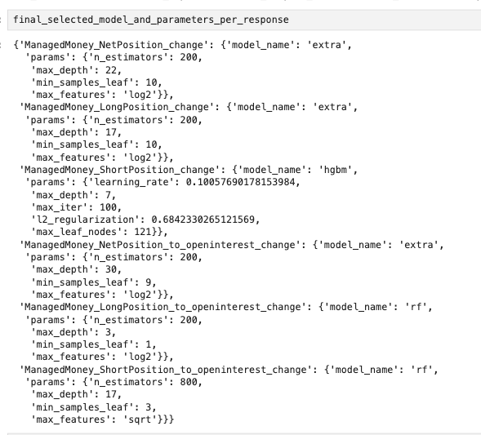

### Forecasting

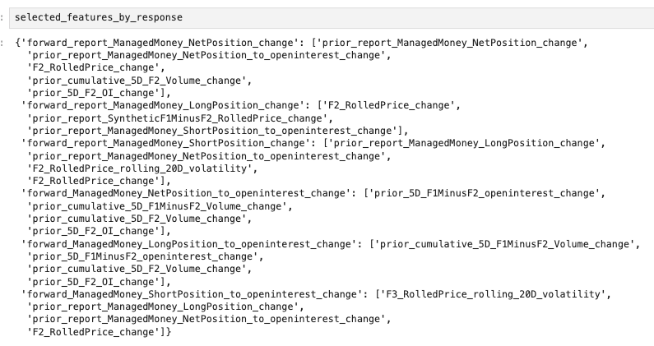

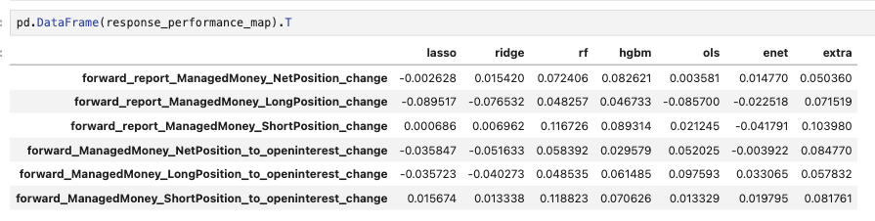

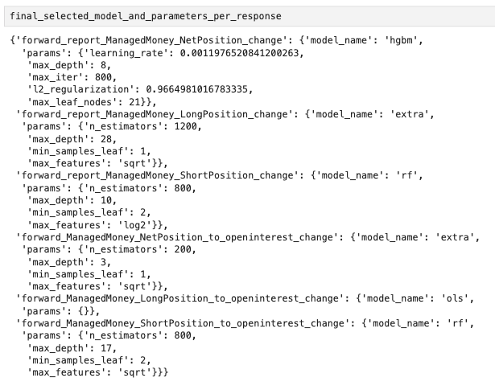

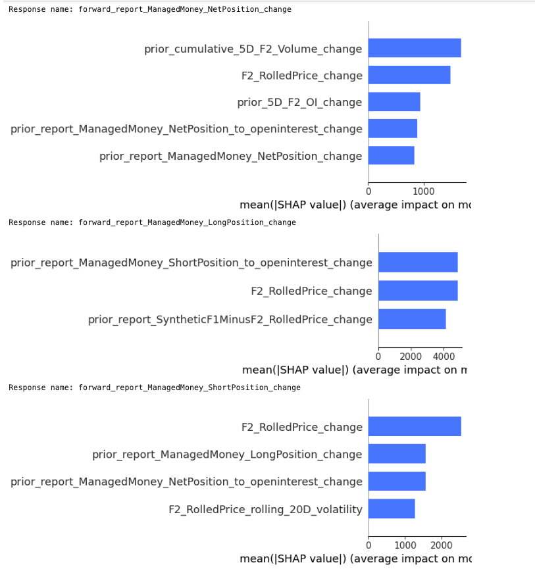

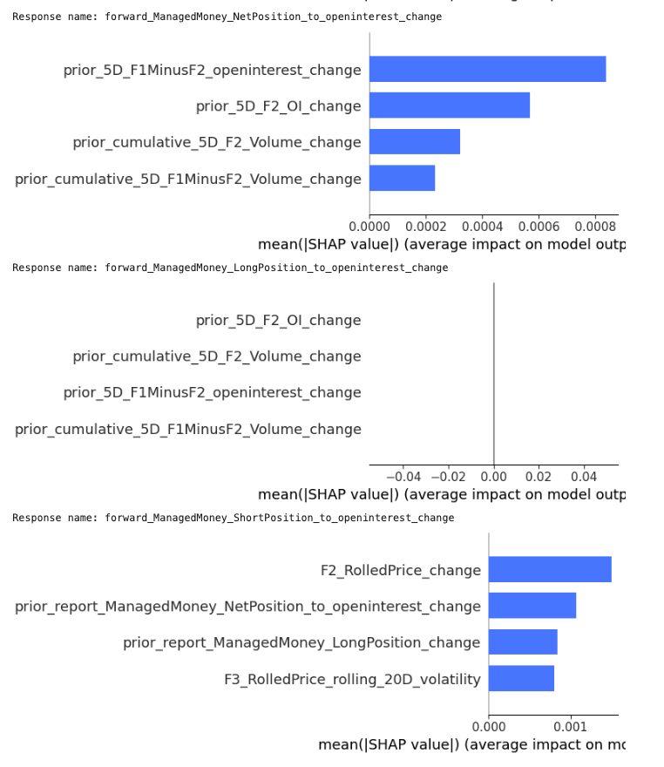

# Brent

## Commercials

### Nowcasting

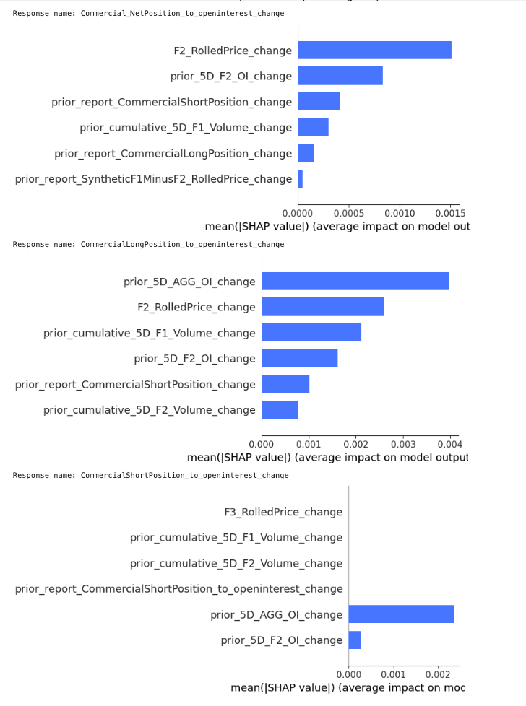

### Forecasting

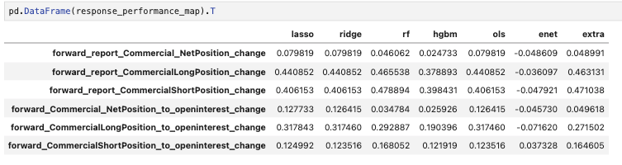

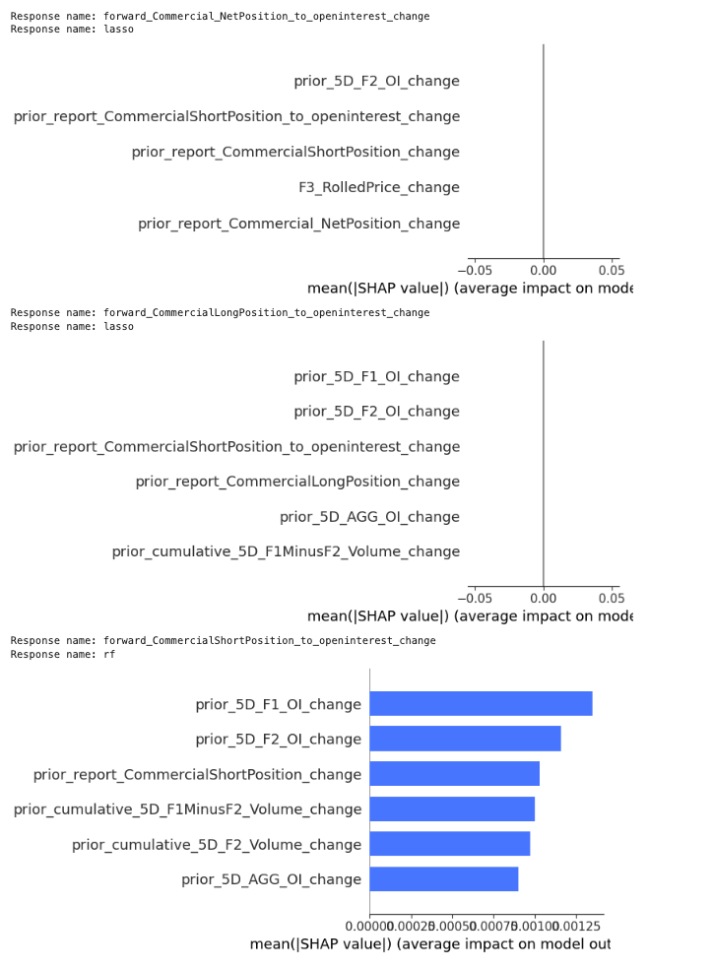

## Managed Money

### Nowcasting

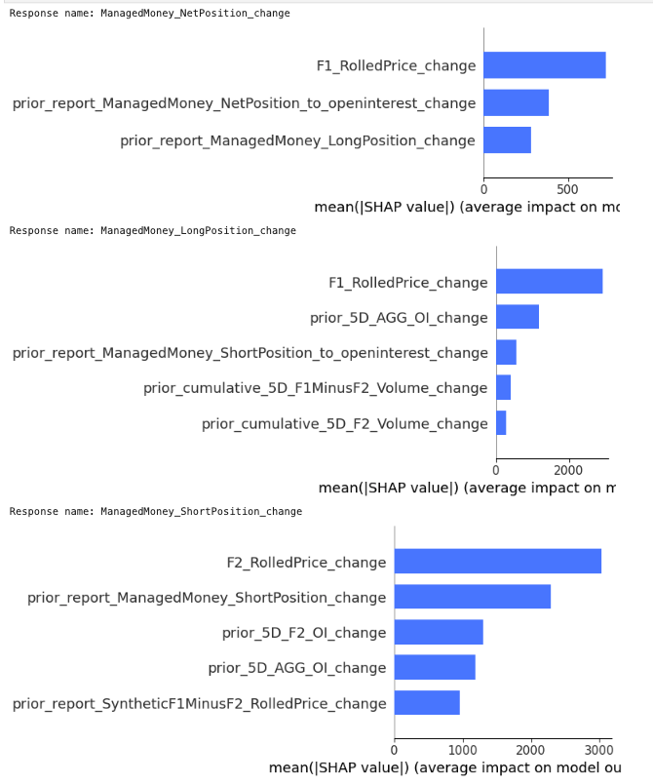

### Forecasting

# Heating Oil

## Commercials

### Nowcasting

### Forecasting

## Managed Money

### Nowcasting

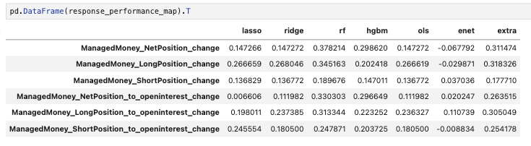

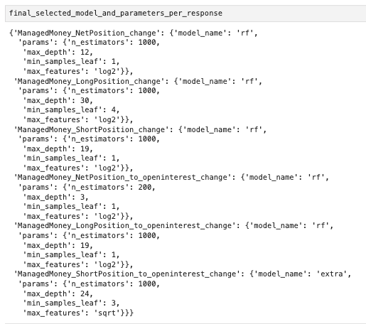

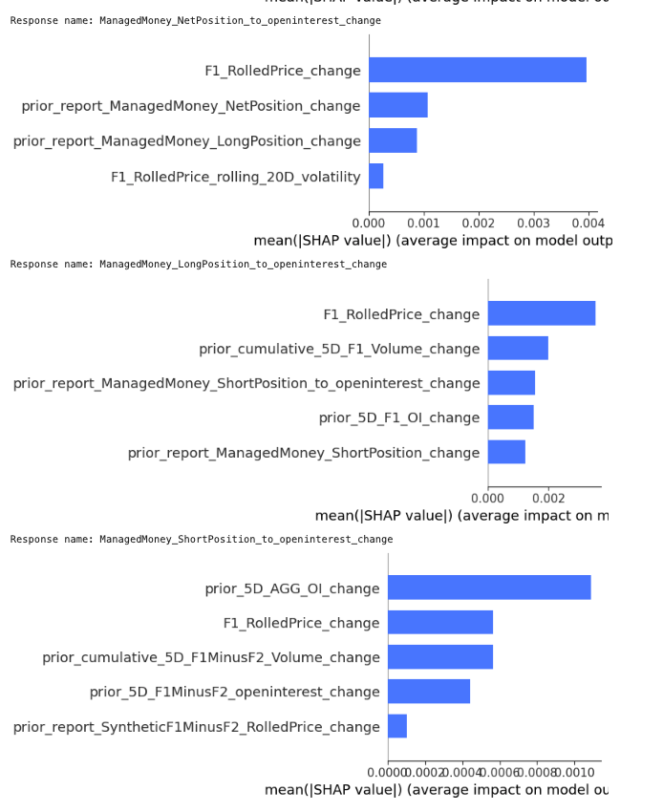

### Forecasting

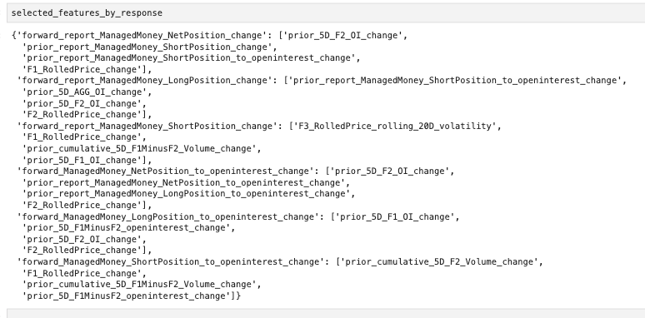

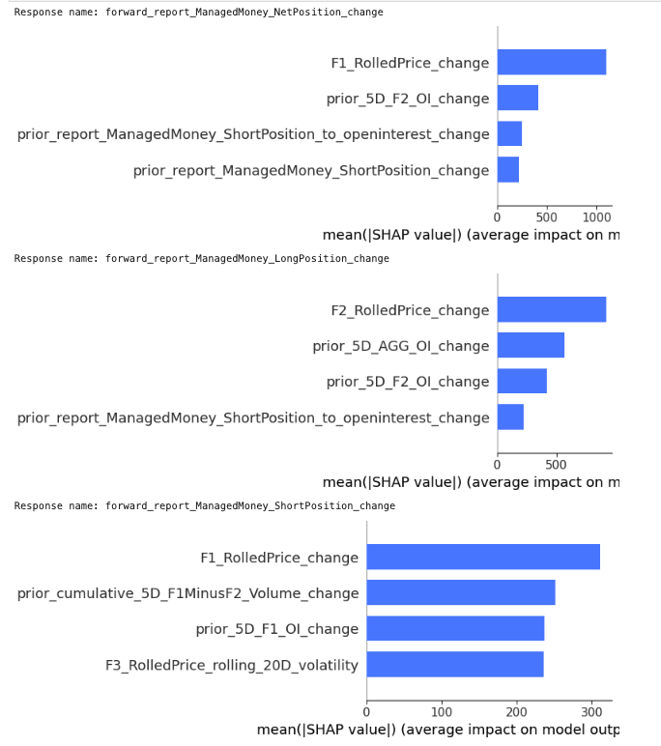

# RBOB

## Commercials

### Nowcasting

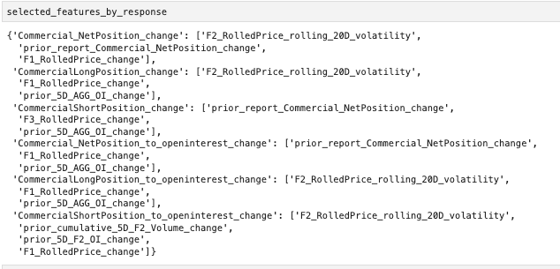

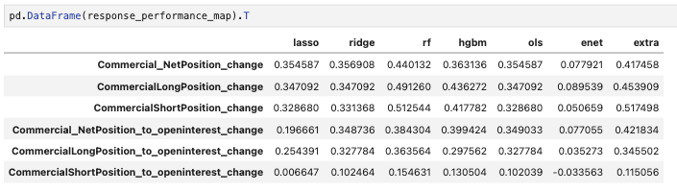

### Forecasting

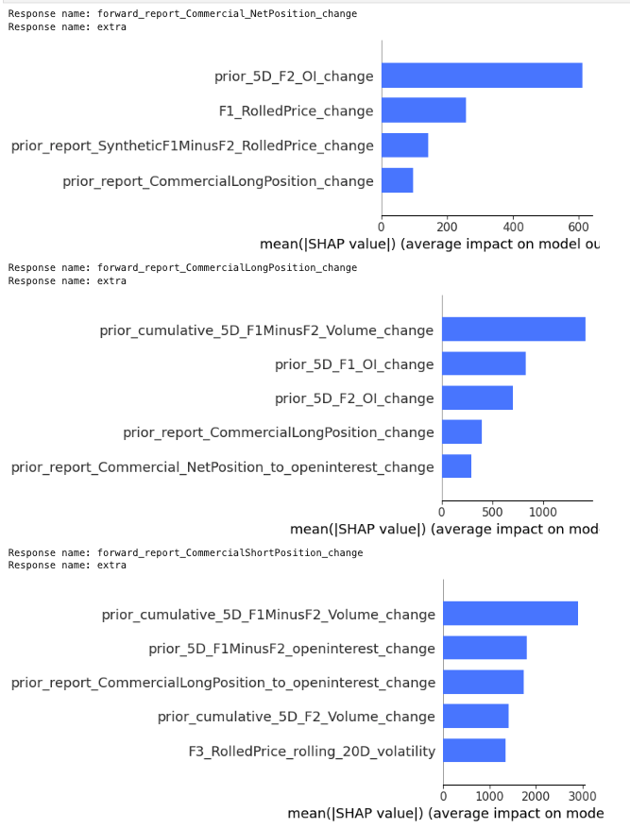

## Managed Money

### Nowcasting

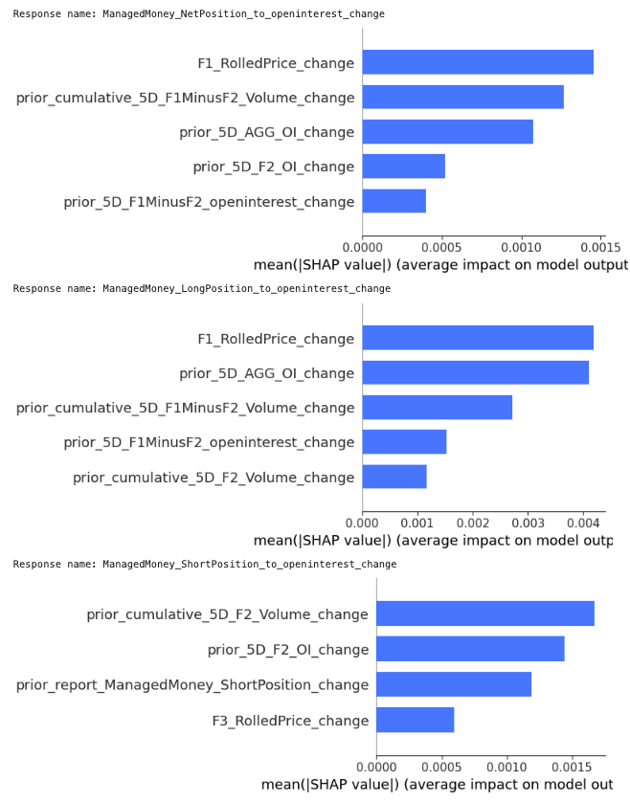

### Forecasting



